Wool: when it drops, it’s a tuft of white wool with W.C. on top. The indicator is on the bottom left hand corner of the map.

What it looks like when dropped:

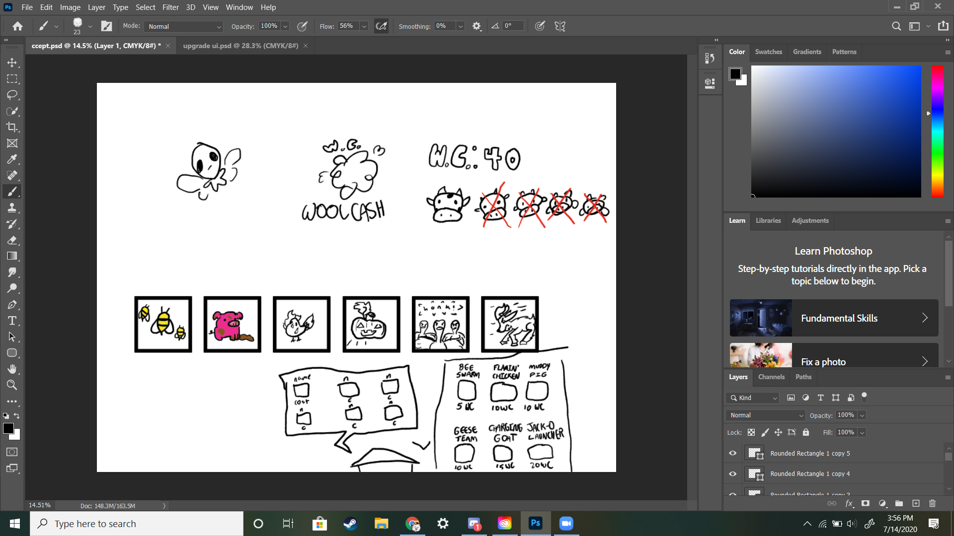

Indicator:



Lives: represented by several cow heads in a row, placed under the barn. When one is lost, a bright red x goes on top of it.



UI for buying towers:

2 rows of 3 tower icons in a dialogue-like box that appears when the door of the barn is clicked. Name of the tower is on top of its icon, and the cost is below. The box has a white background and thick black border, so it stands out against the background. (the right side is the more detailed version)

Ideally, the barn door will light up a different color when moused over, to indicate it can be clicked on.



UI for upgrading towers:

A similar dialogue box as the one for buying towers pops up when a tower is clicked.

(These colors are placeholders)



Tower icons:

Each icon will also have a brightly colored background that contrasts with the animal’s color, ex. bright blue for the bee swarm

Bee swarm:

Three bees, either this or v formation



Mud pig:

a front-facing pig with mud splotches, standing in a mud puddle



Flaming Chicken:

simply enough, a chicken on fire

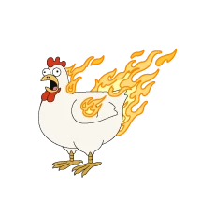

Jack o launcher:

Plain old jack o lantern, possibly with some lines to represent motion



Geese team:

three geese in a v formation, flying? (or just with wings extended?), staring at the imaginary camera



Charging goat:

goat in profile who is charging

(like this, but in more of a running stance)

